Phase 3 Postman

Assisted Practice 17 Name: Prajwal Diwakar

**Fetch Data from CSV and JSON.**

**1)CSV**

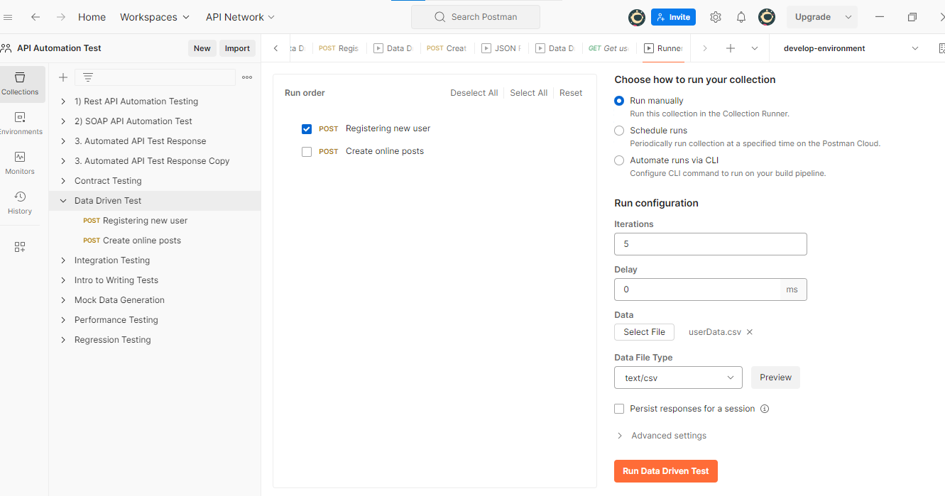

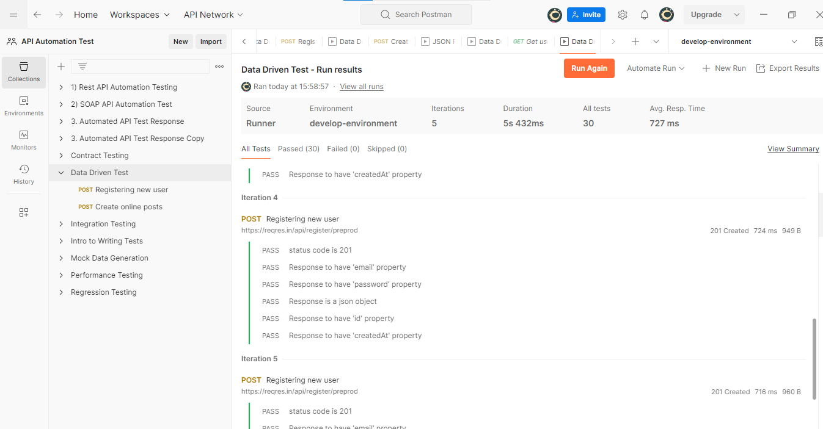

**2)JSON**

